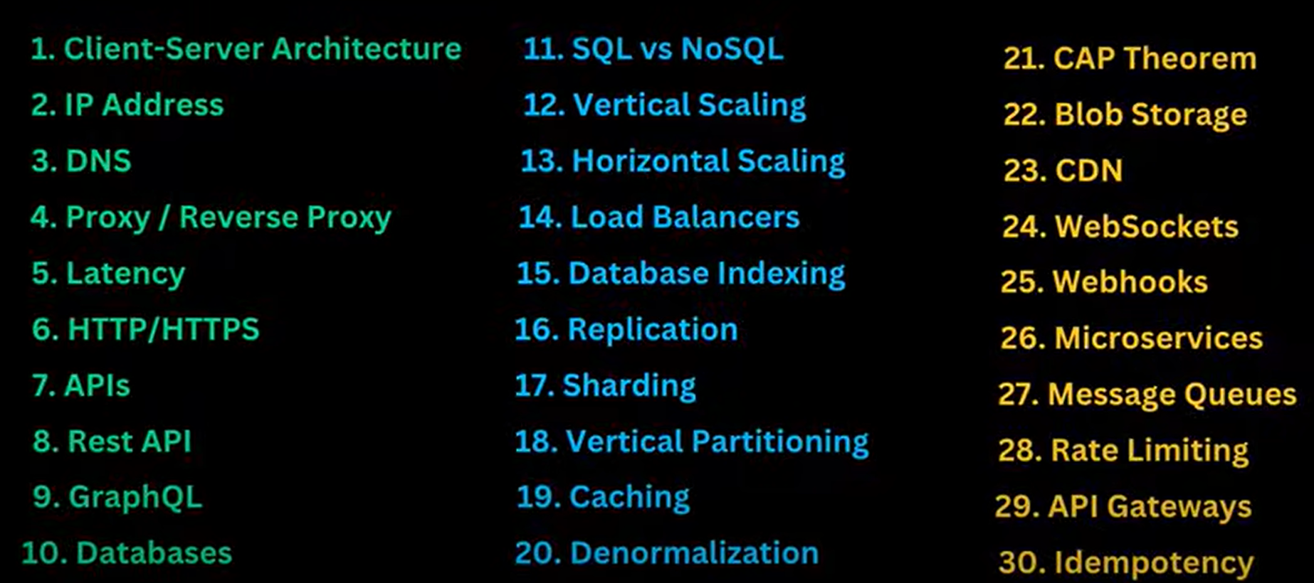

**1. Client-Server Architecture**

Client sends a request to server and server process the request and send back to client.

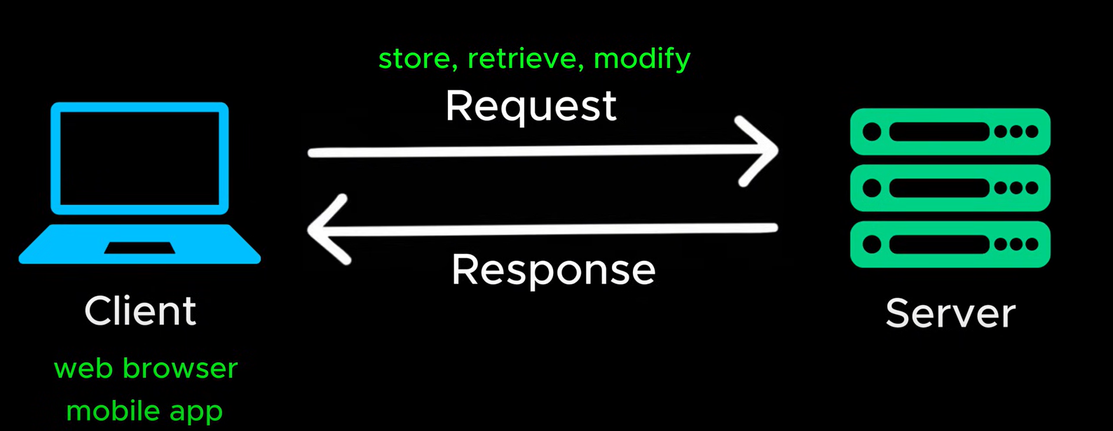

Problem: How does client know where to find server? IP Address will solve this problem.

**2. IP Address?**

In general computers, can communicate through IP addresses.

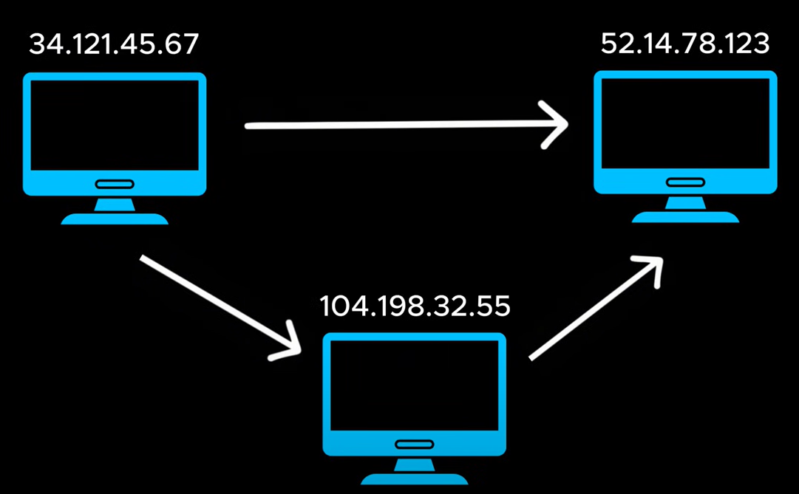

Problem: When we type an URL, we used to search with Google.com, not with IP address? DNS will solve this problem.

**3. DNS?**

Domain Name System will help us to get the IP address of the domain.

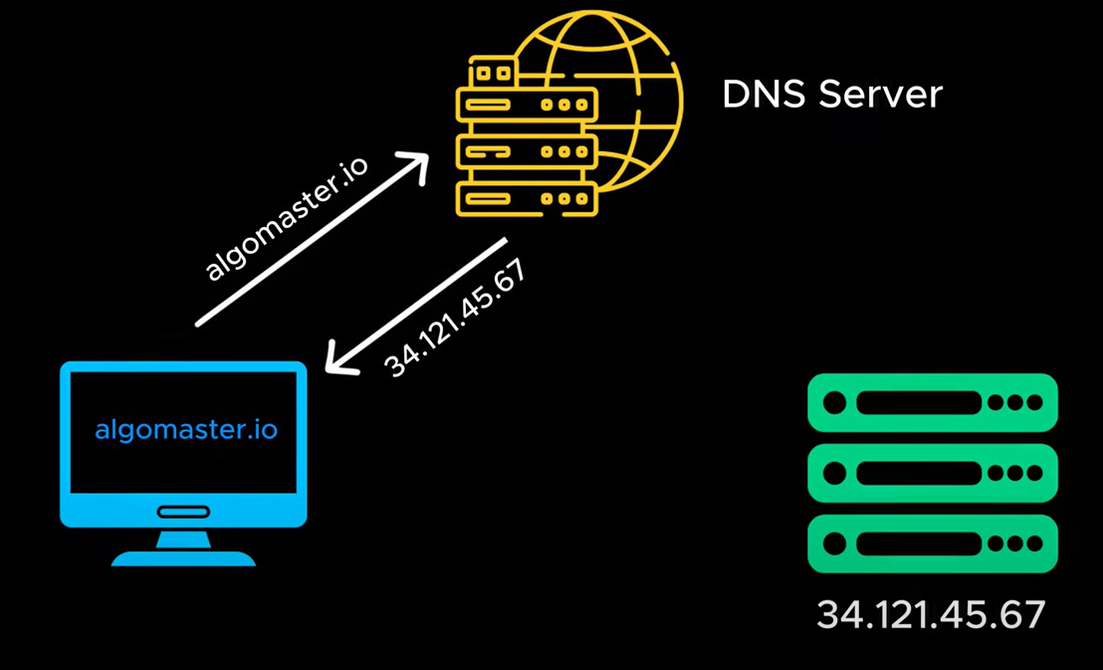

Problem: Sometimes our request not directly pass through the domain server, it may go through proxy/ reverse proxy server.

**4. Proxy / Reverse Proxy?**

Proxy server behaves like a mediator between one or more devices and internet.

Benefits:

1. Protects client identity
2. Hiding IP address of the users, instead it’s visible identity of proxy server.
3. Bypass browsing restrictions
4. Blocks access to certain content.

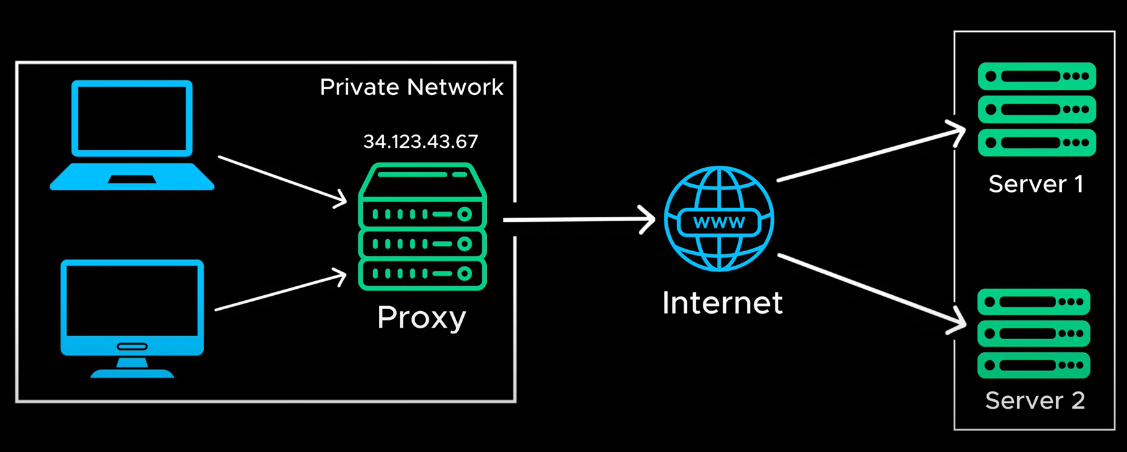

Reverse Proxy:

It intercepts the client request and forward the request to server with predefined rules.

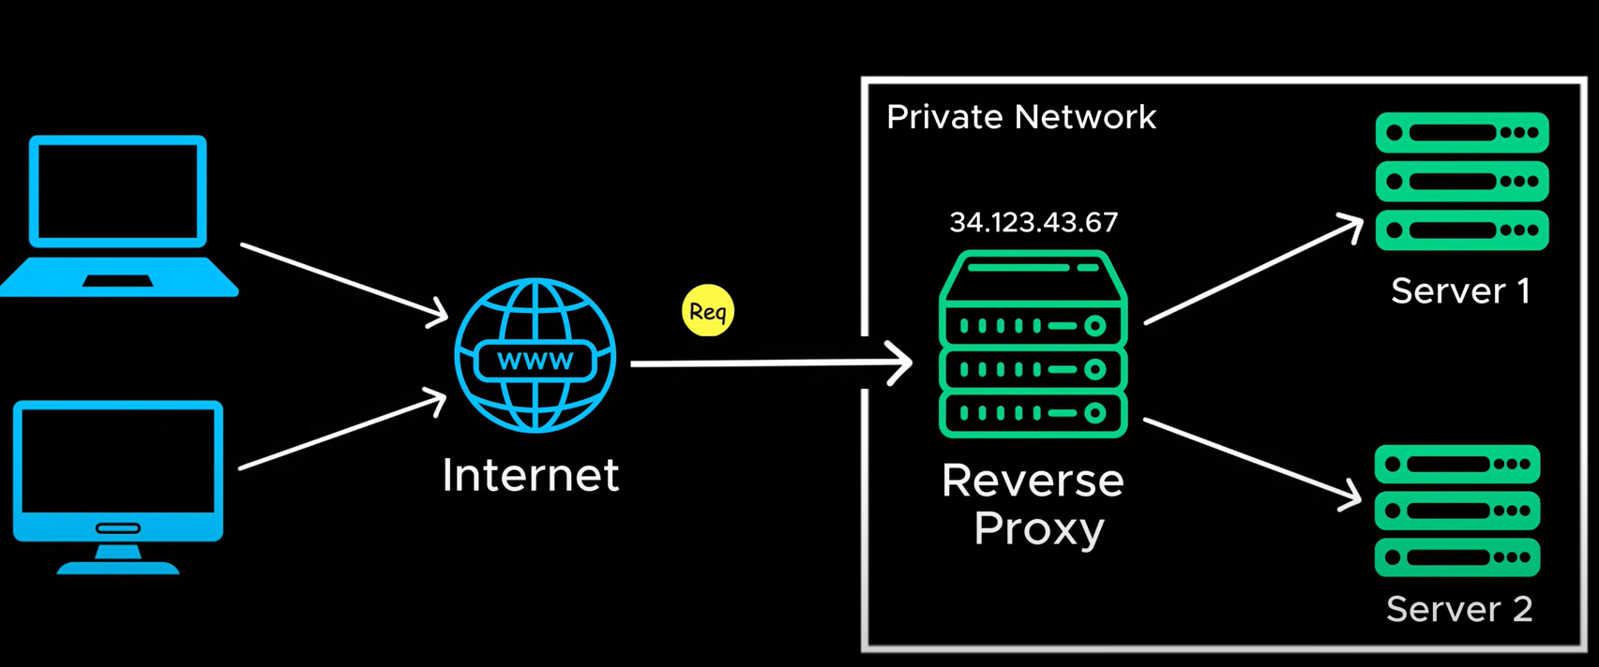

Benefits:

1. Protects server / website identity
2. Uses load balancing
3. Caching
4. Handles SSL encryption

Problem: If client is in one place and server located far way, then there is a delay in server response. To avoid this problem, we are using LATENCY.

**5. LATENCY**

High latency will decrease the application performance, to solve this we can deploy multiple data centres on each location. So, rather take a request from long distance server, it will fetch it from nearby server and process the request.

Ex: amazon.in, amazon.ae …

Problem: How does client send a request to nearest server? We can solve this using HTTP/HTTPs.

**6. HTTP / HTTPS**

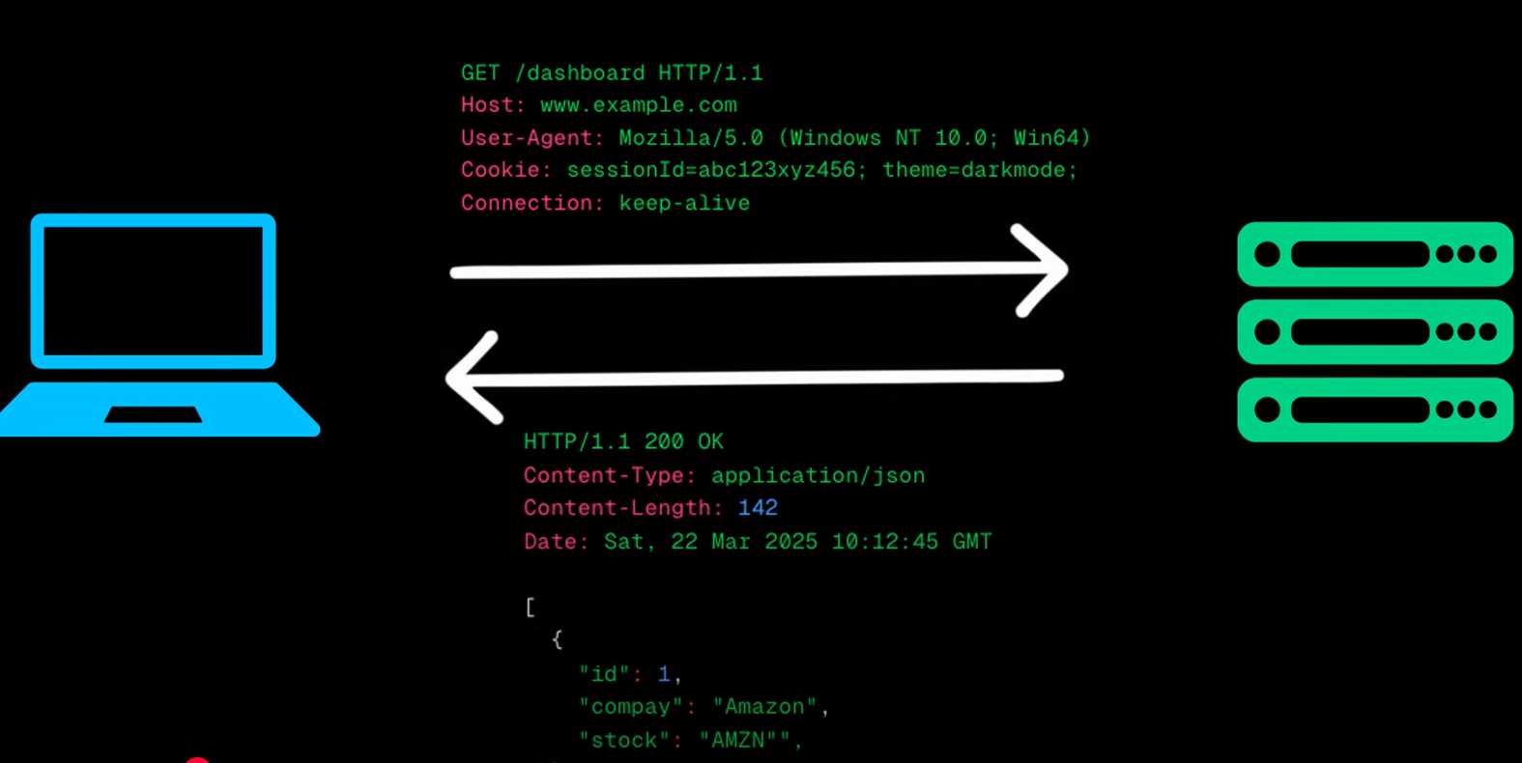

Problem: HTTP/HTTPS doesn’t define input or output structure; it simply sends the request from client to server and take response. To solve this, we have a concept called API’s.

**7. API’s (Application Programme Interfaces):**

API’s act as a mediator between client and server by passing structured data from client to server and response the same structured response to client.

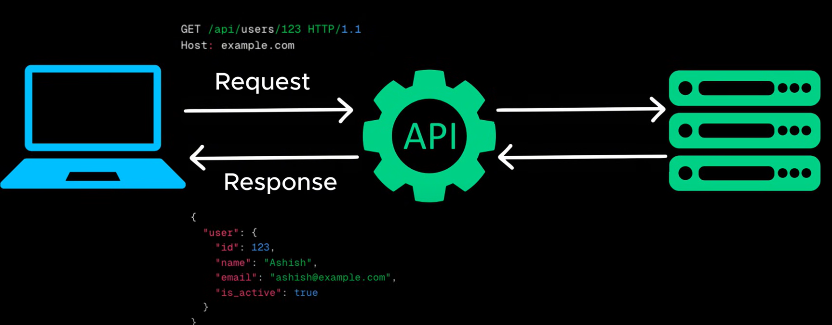

Problem: Which API styles we need to use REST / GRAPHQL

**8. REST (Representational state transfer)**

REST defines how client and server communicates with each other in a structured way.

Rest is stateless, so every request considered as a new request.

It uses standard HTTP methods GET, POST, PUT, Delete.

Problem: it has limitations when dealing with complex data types, it gives the unnecessary results than needed in headers and other formats, to avoid we have a concept called GraphQL.

**9. GraphQL**

It gives only necessary details to client.

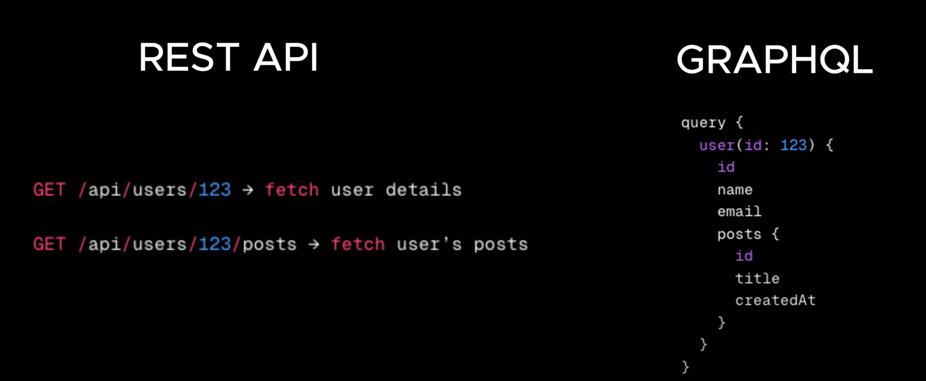

Problem: Where we store this data to fetch? The solution is Database.

**10. Database**

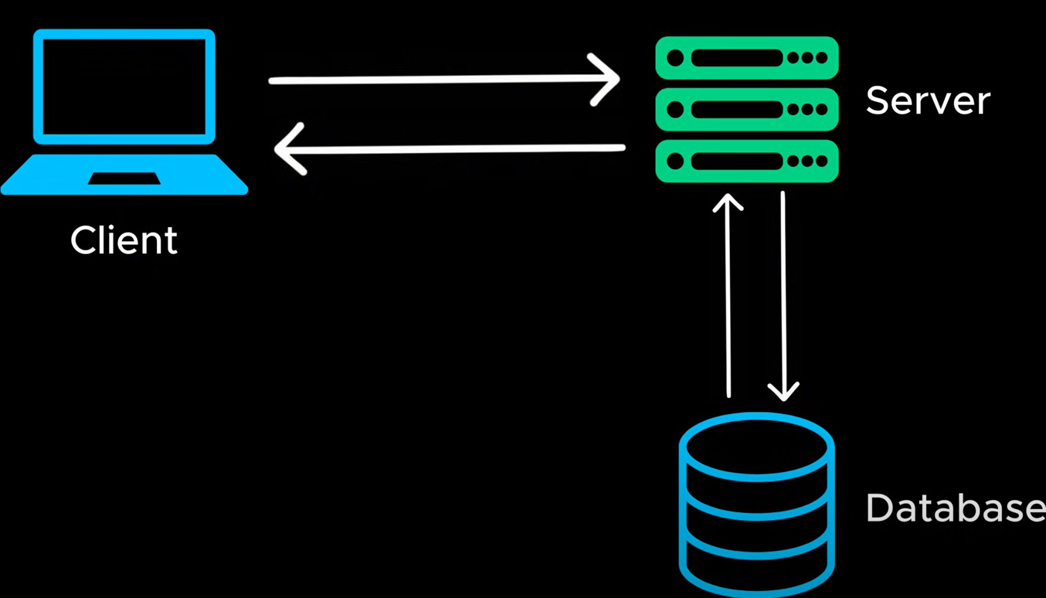

Problem: What type of database we need to use, Structured (SQL) or unstructured (NoSQL) database?

**11. SQL or NoSQL**

SQL is structured database; it contains tables in Rows&Column defined structures with predefined keys and indexes etc.

NoSQL is don’t required structure; it uses to improve application performance as there is no flexible schema to define.

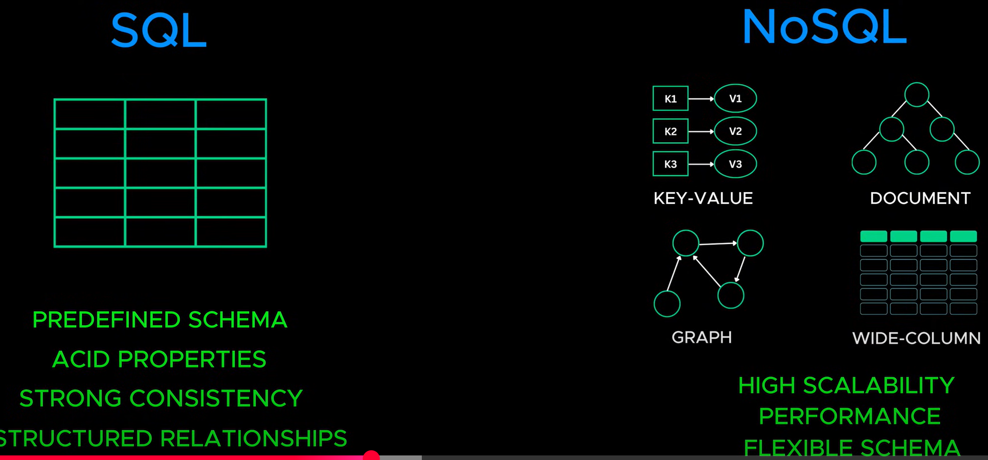

Problem: When USERS increases it will impact application performance to fetch details, the solution is VERTICLE SCALING.

**11. VERTICLE SCALING**

We can increase the server CPU, Memory etc but there are some limitations to increase.

Problem: To resolve the limitation problem, we have a concept called HORIZONTAL SCALING.

**12. HORIZONTAL SCALING**

On top of Verticle scaling, if the application is still down, we can go with Horizontal scaling by adding multiple servers.

By this way, if one server down then it will fetch details from another server.

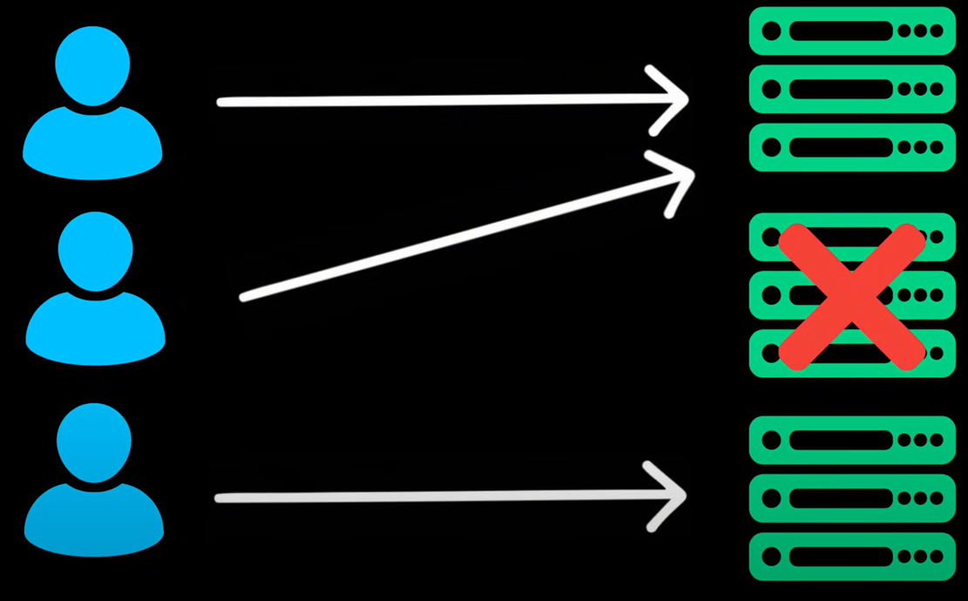

Problem: How do client know, which server to connect, this is how a concept called Load Balancer comes in picture.

**13. Load Balancer:**

Load balancer acts like a traffic manager, if one server breaks down, it will redirect to the healthy or another active server.

**14. How does Load balancer assign next server?**

We have an algorithm for that like

Round Robin – repeating sequence, next server definitely be least recently used or LRU

Least connection – this handle previously connected resources

consistent Hashing – similar to DB hashing, the resource might be assigned based on IP address

Problem: What if the application performance is still down, we can implement scaling on DB servers like horizontal and vertically.

**15. Indexing**

Indexing will help us to concentrate on indexed column rather to focus more on entire table. It helps to improve application performance for read.

Problem: If still it has performance issues post indexing, we have a concept called REPLICATIONS.

**16. REPLICATIONS:**

We can maintain duplicate servers and one server as a primary replica. If primary server breaks down, automatically any other server takes a responsibility and act as a primary replica.

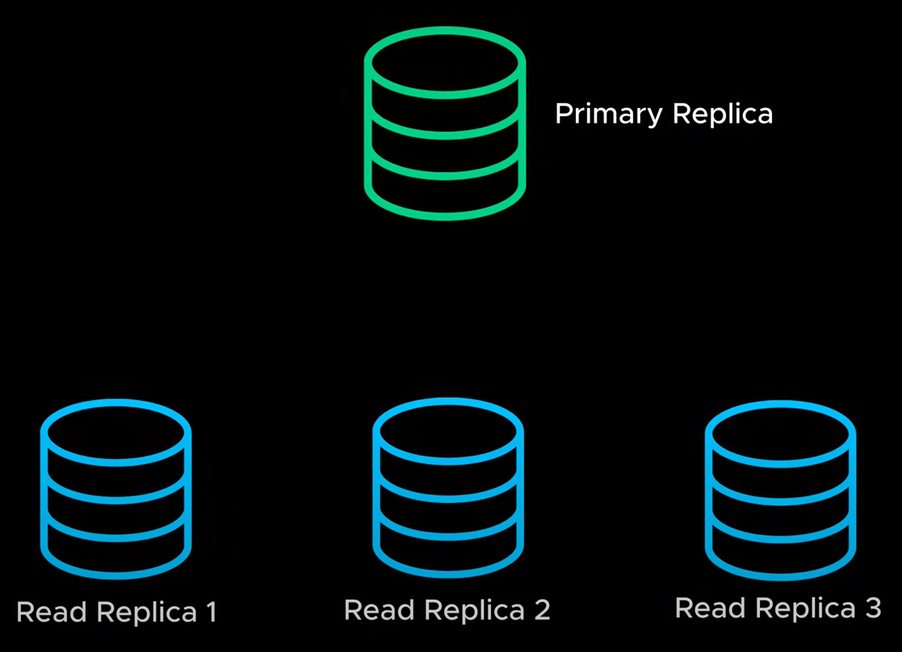

Problem: Replica helps to improve performance for read but fails to improve on Write. To overcome this problem, we have a concept called SHARDING.

**17. SHARDING**

We divide data into multiple servers based on Key.

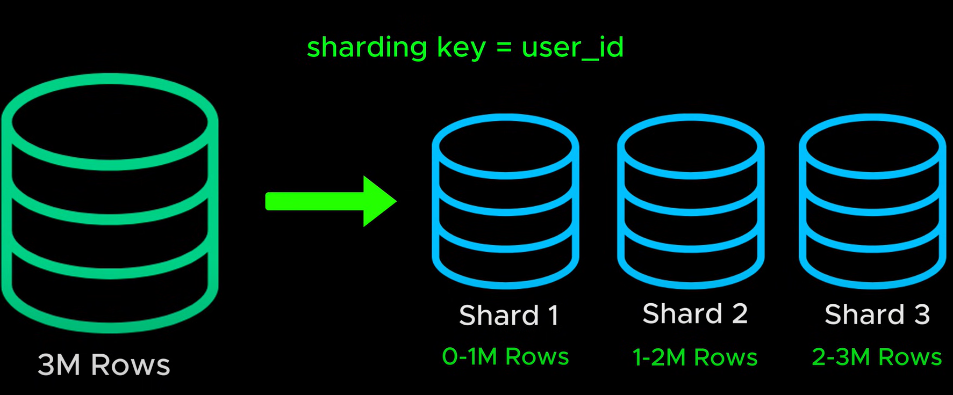

**18. Vertical Partitioning**

We started table creation with specific columns, as days passed, we added unnecessary fields into it. So, it’s heavy weighted to use the table for unused fields.

The solution is to split up database tables into smaller chunks.

**19. Caching**

Caching helps to store DB data in-memory and subsequent request it fetches from cache rather to fetch from DB.

It helps to fetch data from cache rather to get it from DB for every request, to reduce time.

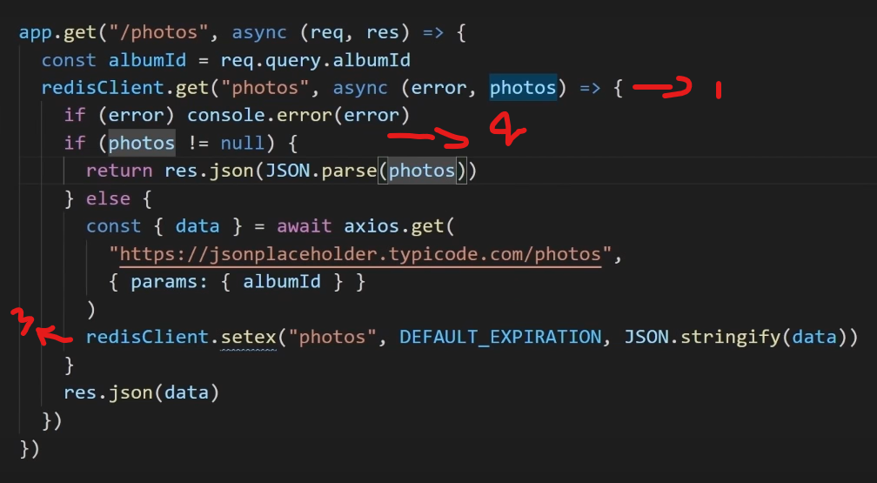

1. Trying to get data from Redis Cache
2. Check whether data is present in Redis cache or not
3. Set data into Redis Cache.

**20. Denormalization**

As part of normalization process, some scenarios for one or very few fields we unnecessarily create new table and join that table with parent, this also degrade performance as data grows.

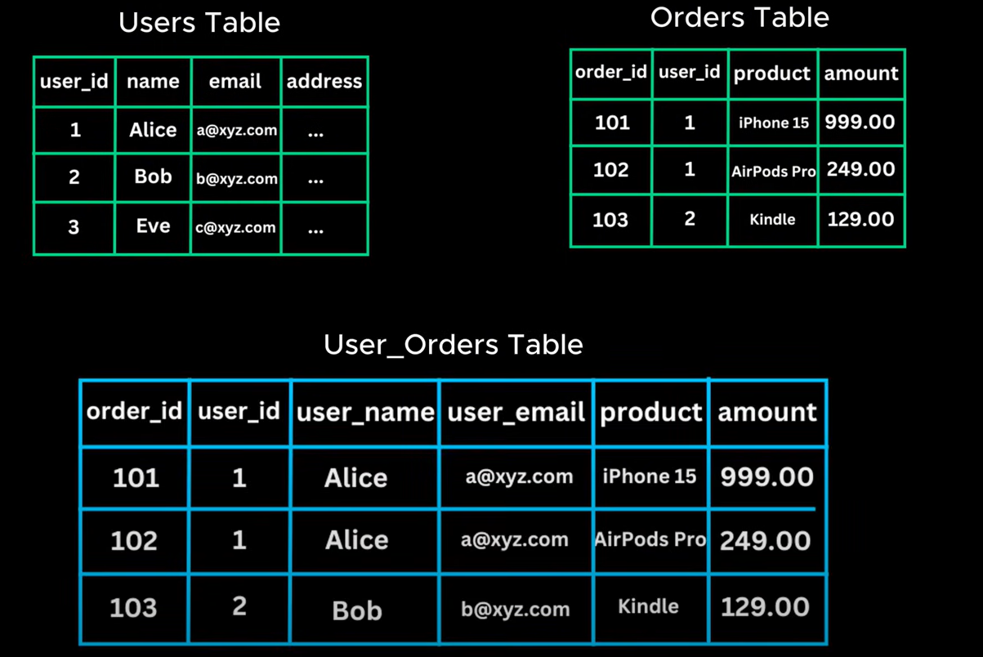

**21. Blob Storage**

Sometimes we may need to store images and files. Blob storage will help us to store this kind of data.

Problem: If I want to watch a youtube video where it is hosted in far away country, then it will lead to buffering, to avoid this, we have a concept called CDN.

**22. CDN**

Content Delivery Network act as a distributed system and fetches the videos based on your geo graphical design.

**23. Web Sockets**

HTTP helps to take a request from client and send to server, once server process that request and then it will send the response back to client. This is one way communication from HTTP. It’s uni-directional or stateless protocol.

What if I want to design an online chat application?

Http won’t help us to fix this problem, to solve this we have a concept called Web Sockets, this helps to real time communication.

1. First Client sent connection request to server via http
2. Server responds with status code 101, it gives a handshake to open web socket connectivity.

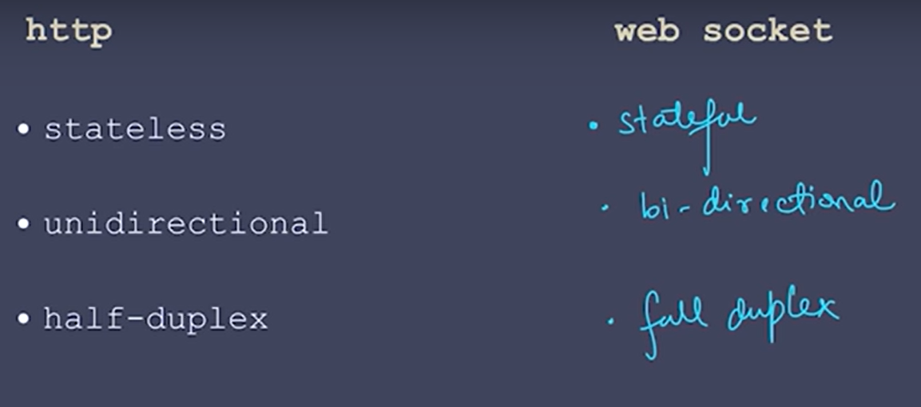

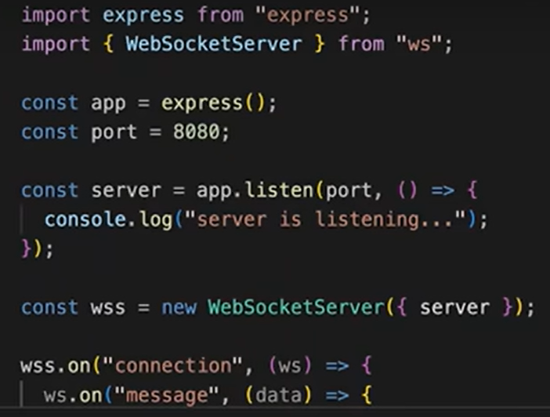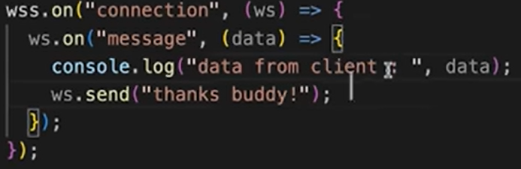

**24. Microservices**

Microservices help us to split the large api services and related DB’s into smaller chunks.

Problem: Communicating between services via api calls is always not at all good. This is way message queues come in picture.

**25. Message Queues**

Message Queue enable services to communicate asynchronously, without blocking another request.

Problem: How do we prevent overload on public API’s.

**26. Rate Limiting**

It defines the specific request for the time frame, if the requests exceeds then it will block the further requests temporarily by using algorithms like

Fixed Window – it will process the requests for fixed time frame

Sliding Window – It will be tweaking window based on request pattern

Token bucket.

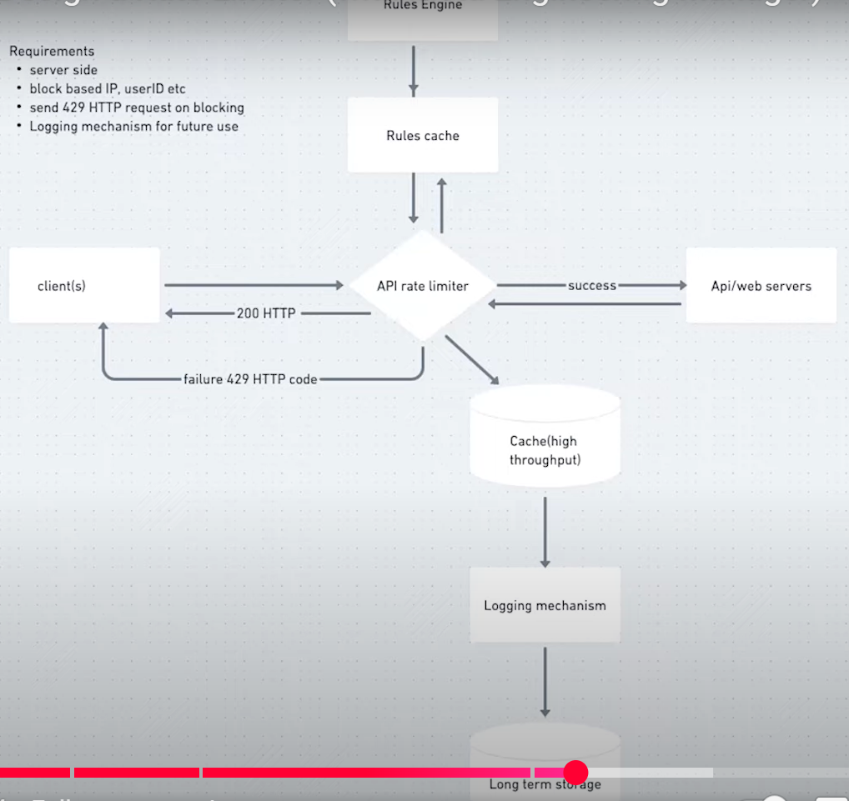

**27. API Gateway**

API gateway deals all above features by default. It is the mediator between client and micro services. It improves application scalability and security.

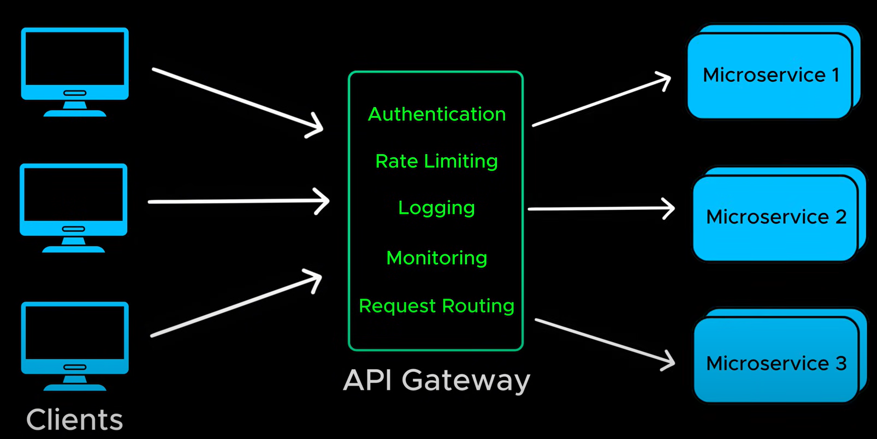

**28. IDEMPOTENCY**

When we are working on payment gateway system, during the processing the request if the page gets refreshed 2 entries were created.

To avoid this, we used IDEMPOTENCY and it creates unique Id for each request, if the request 1 is already processing then it will ignore second request.

**29. Kafka**

The real-life example for Kafka is E-commerce website, for ex: If we order pizza from dominos, it handles multiple services like payment gateway, orders page, notifications to send an email, order tracking etc. If one service fails due to our TIGHTLY coupled architecture entire website crashing, and customers can see loading screens on browser.

How Kafka solve this problem is, first it removes tight coupling, rather direct interact with the service, it will communicate through mediator. Here, KAFKA is a mediator.

For ex: Amazon delivery system, amazon directly won’t deliver product to customers, rather it will hire the separate delivery team for pick-up and delivery.

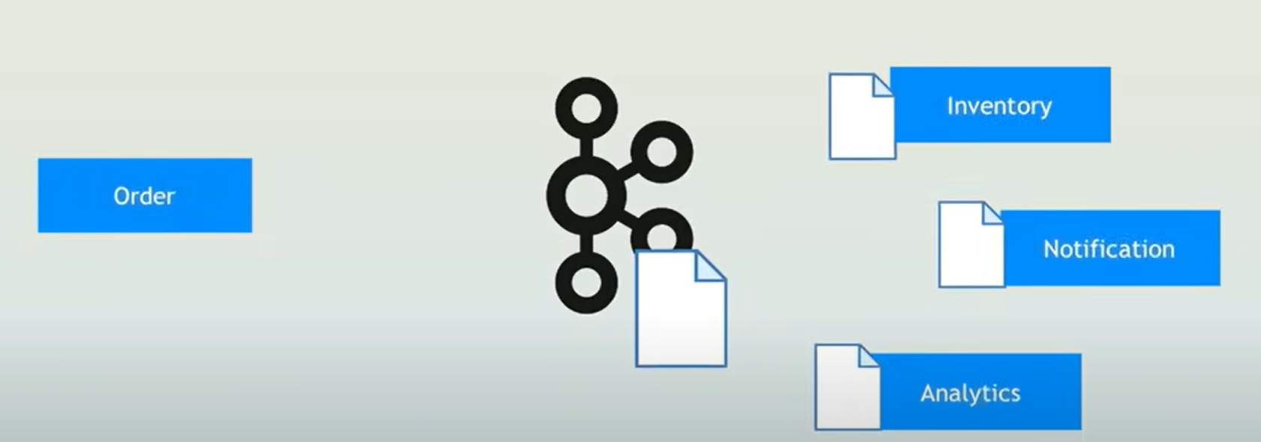

Kafka is generally a producer.

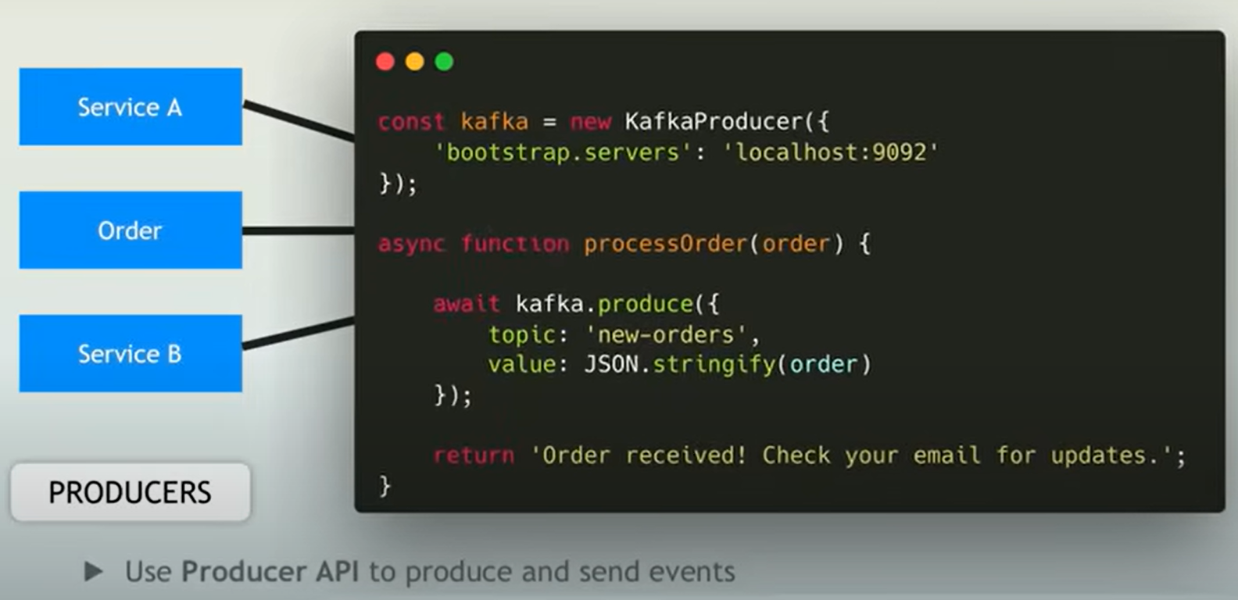

**30. Choosing between servers?**

**SOAP**: useful when we are working on banking applications or some sort of security applications. But it’s not good fit when are working with lightweight applications, it impacts in app performance.

**RESTful**: it is good fit to connect with over http for lightweight applications like youtube, twitter etc, but it fails to hold **bi-directional** communication as it is stateless protocol.

**GraphQL**: it avoids unnecessary data to be fetch, rather it will fetch whatever data is necessary to the client.

**gRPC**: it is preferrable to use when we are working with micro service architecture

**WebSockets**: it’s preferrable for Bi-Directional communication like chatting applications, trading applications etc.

**WebHooks**: it avoids unnecessary load on the server, as it will trigger events based on updates available.

For ex: Facebook, sent a notification to the users whenever there is any updates on his profile.

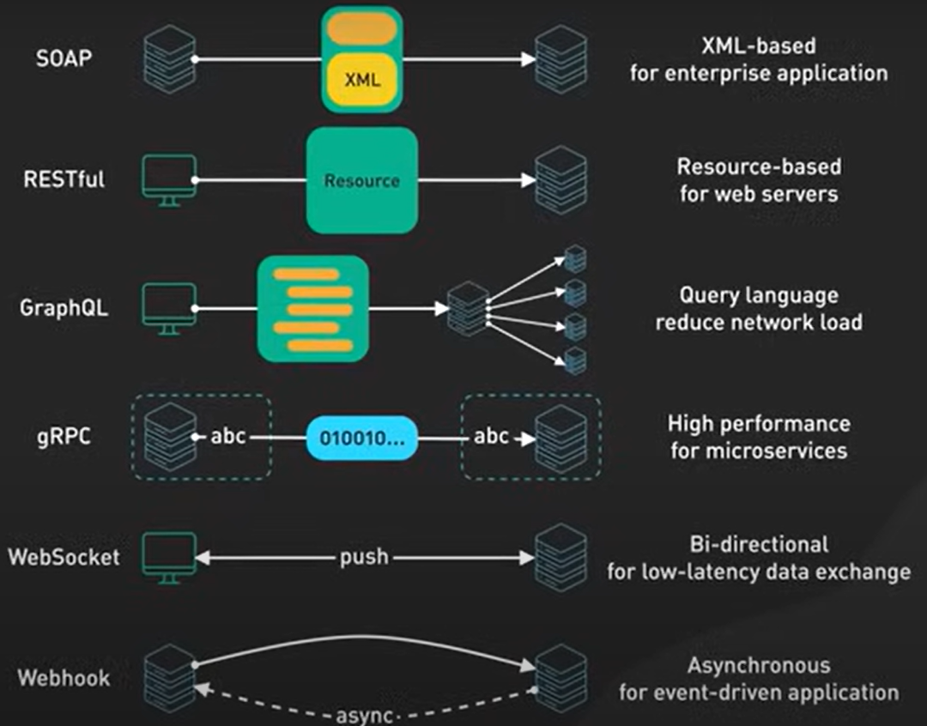

**31. Choosing between Load Balancer, Reverse Proxy, Proxy and API Gateway?**

